Abhinav Komaravelli

Oluwapelumi Omole

Alec Handal

Quiz 4: MODS APPS

# Bugs:

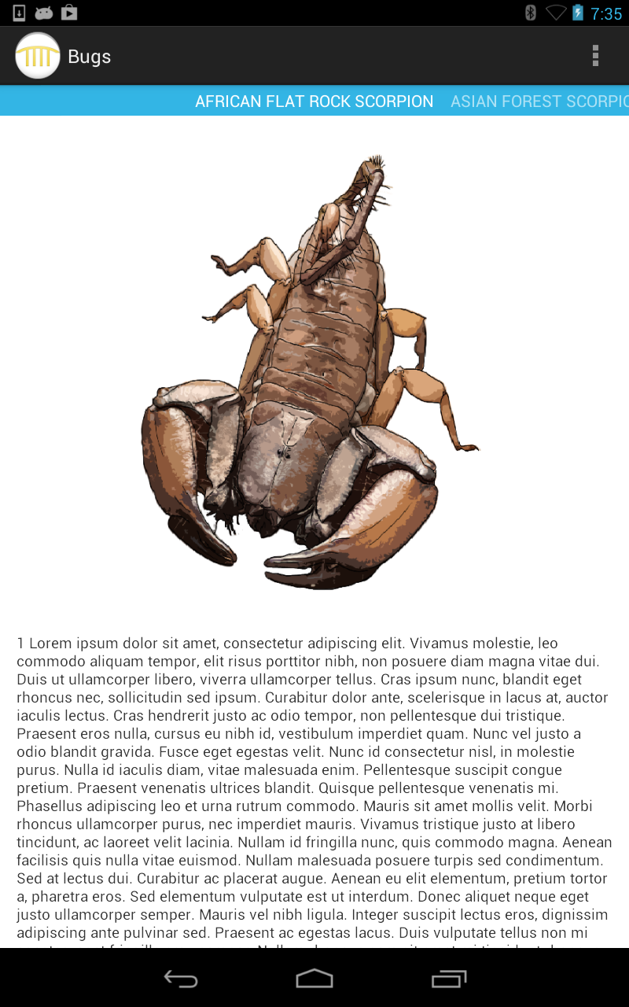 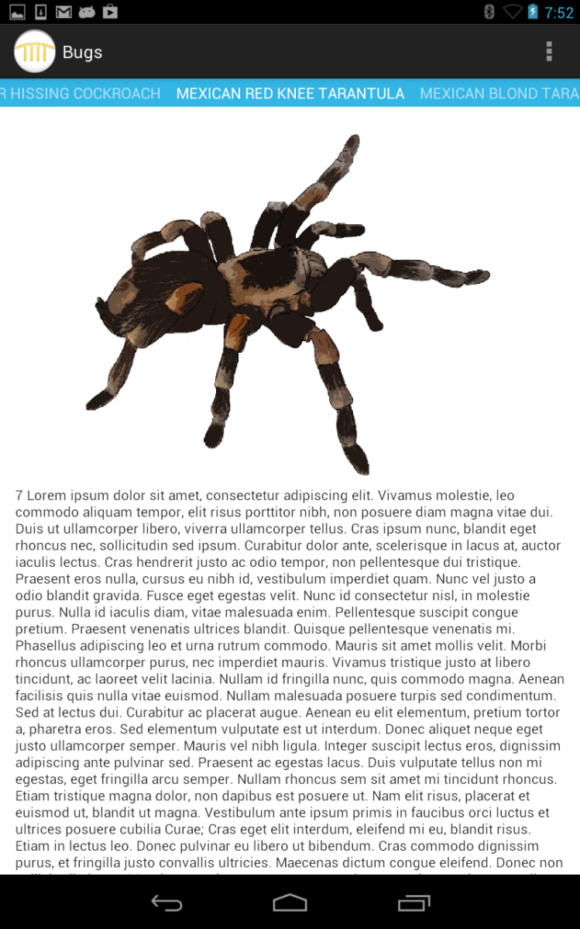

The Bugs MODS app has a very simple UI layout. When starting the app, a picture of the African Flat Rock Scorpion pops up with text under it (assuming it is information about the species). The user can scroll down to read the remainder of the text on each species of bug. To be able to store information on multiple bugs, a feature was created so that if the user swiped left or right, pictures and text of mores species popped up. This is extremely convenient for the user as they can access all the information so easily. Although this is true, there is no special button or action that occurs if clicking the insect. There is no other page it leads to, just swiping left and right, and scrolling up and down.

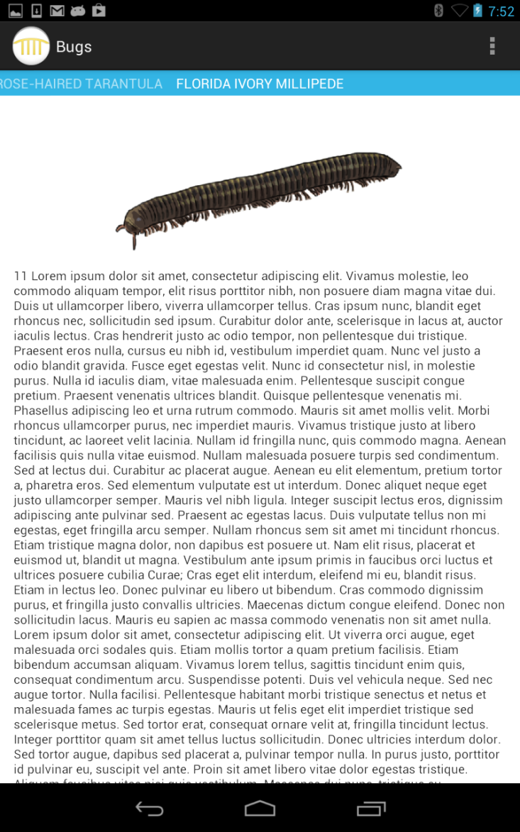

After swiping many times, the user will reach and end and it will be an informational page on the Florida Ivory Millipede.

There is a logo at the top left which does not serve any purpose as a button, but rather just for show. There is also a menu button at the top right (represented by three vertical dots), but if clicked, it displays an option for “Settings”, and this button does not do anything. Therefore, this menu button does not serve any purpose either. In the coding, the pictures are found under “drawable-hdpi” under the “Res” folder.

# Aquarium:

This app was a bit more complicated, but better than the Bug MODS app. The UI layout was similar, other than the fact that it had showed a menu screen when the app is started. There are buttons on the menu screen that lead to different sea creature exhibits. After a button is clicked, it goes to a sea creature that lives in that exhibit and then everything from now on is similar to the Bugs MODS app. There are a series of sea creatures that live in each exhibit, so the user can swipe left and right to see all of them, and even scroll down to read all the information recorded on each sea creature. One extra feature shows up unlike the Bugs app. If the picture of any sea creature is clicked, a pop-up appears saying “Did You Know?”, and this is to give an interesting fun fact of the sea creature. The following page contains pictures of the app and several sea creatures from each exhibit:

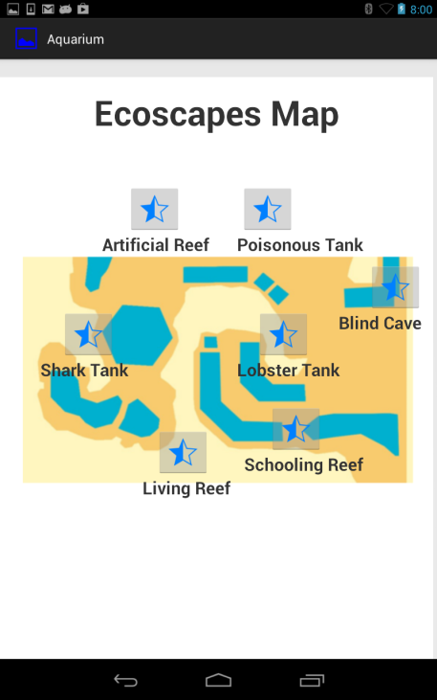

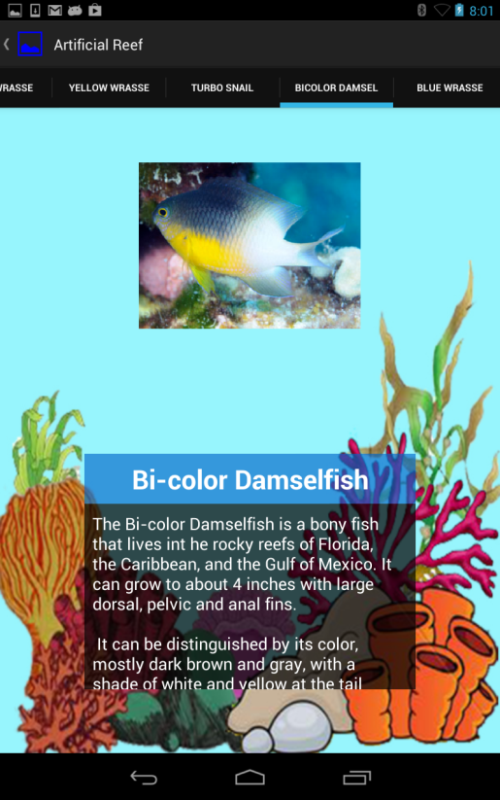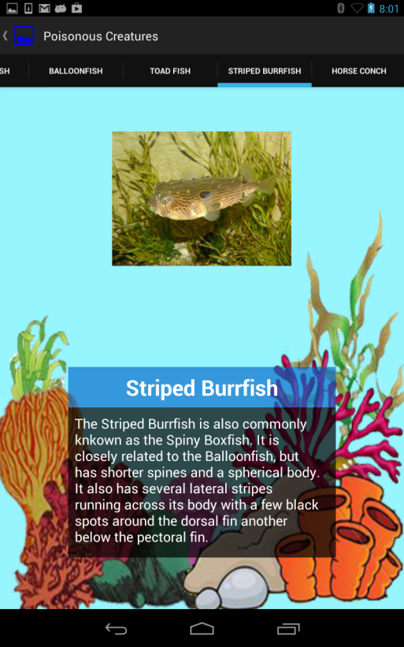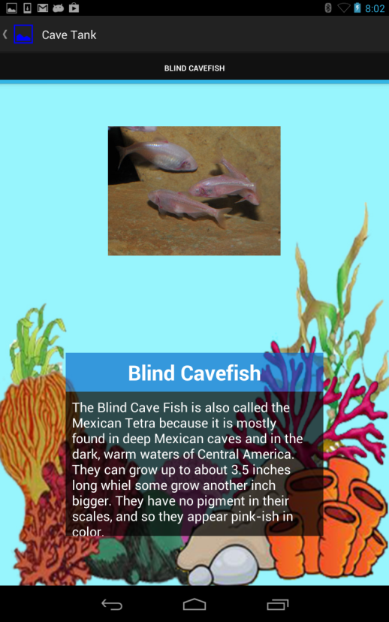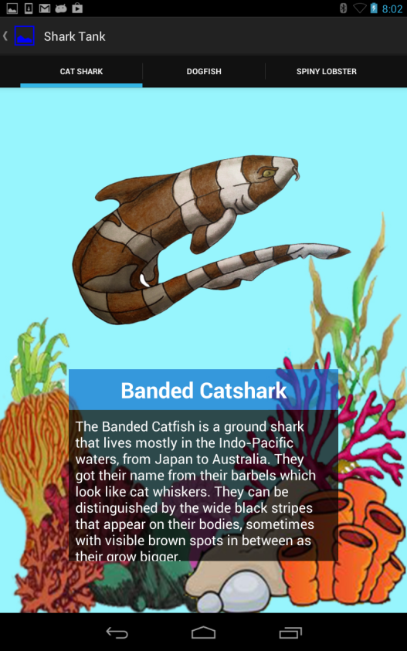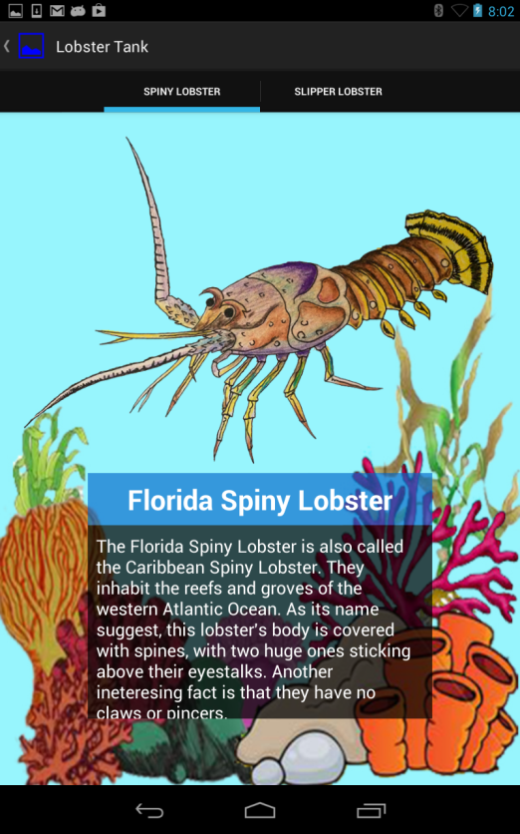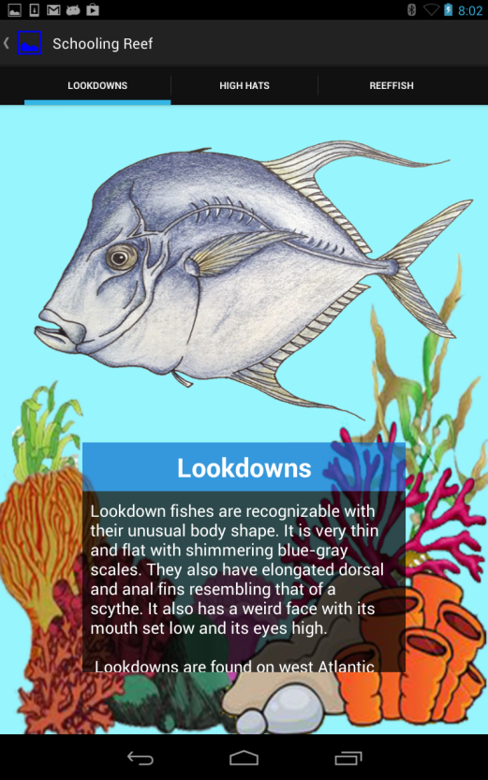

Also, the pictures for each sea creature are stored in “drawable-hdpi” under the Res folder, just like the Bugs MODS app. All in all, these two apps are extremely similar in regards to the UI layout and interactivity. The aquarium app just has an extra feature and a menu screen for excellence.

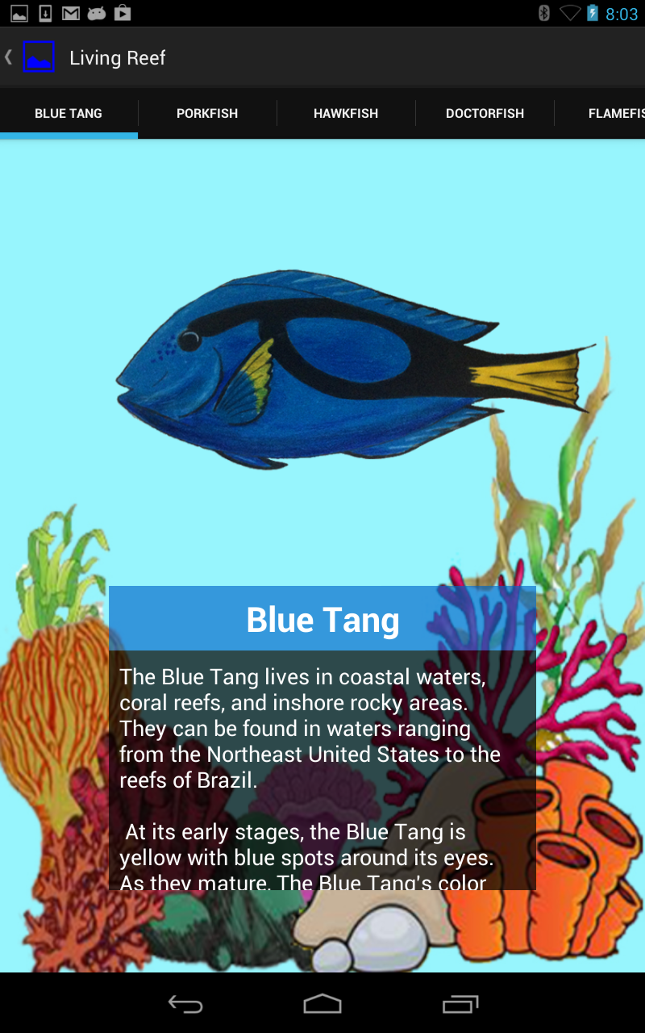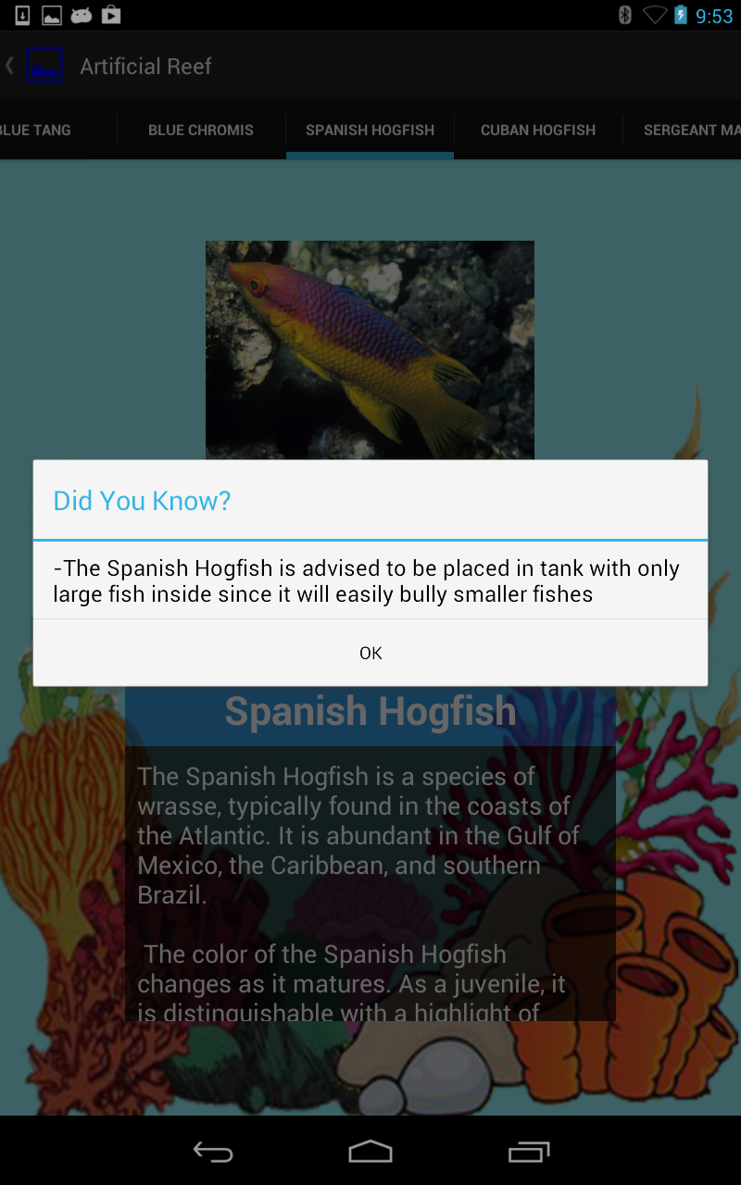

# Detect Robot:

When the app was first launched on the Nexus 7, it simply produced a gray blank screen. What I realized it that the camera shows up after one tap on the screen. According to the code, the camera only functions at 10 frames per second (fps). If tapped one more time, the camera peruses the picture for any green pixels and it would shade those regions in RGB mode. The majority of a pixel must be green in order to be identified as green.

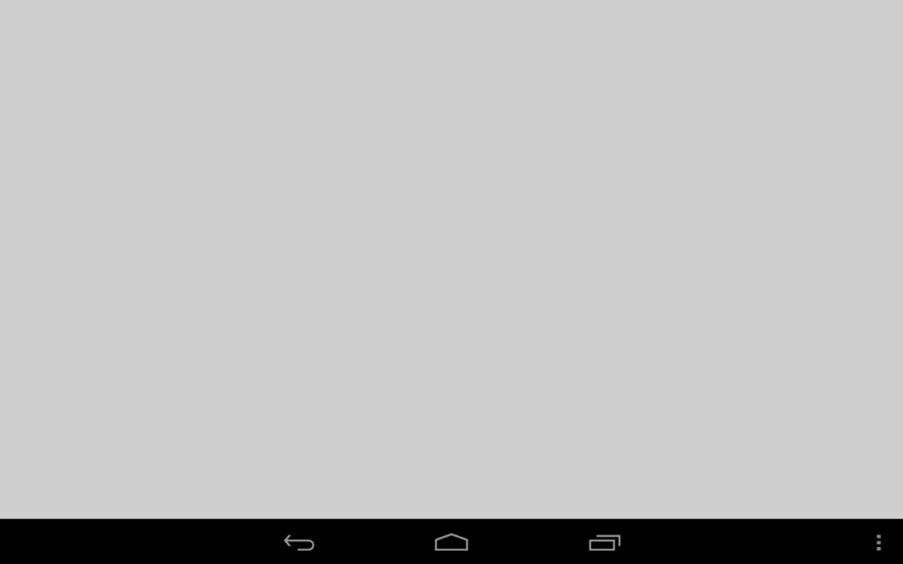

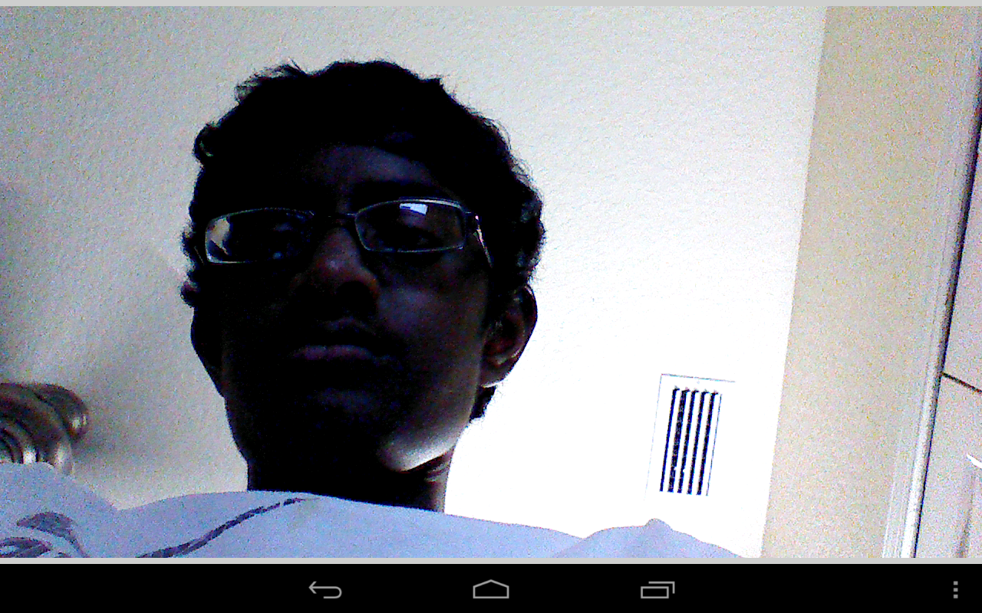

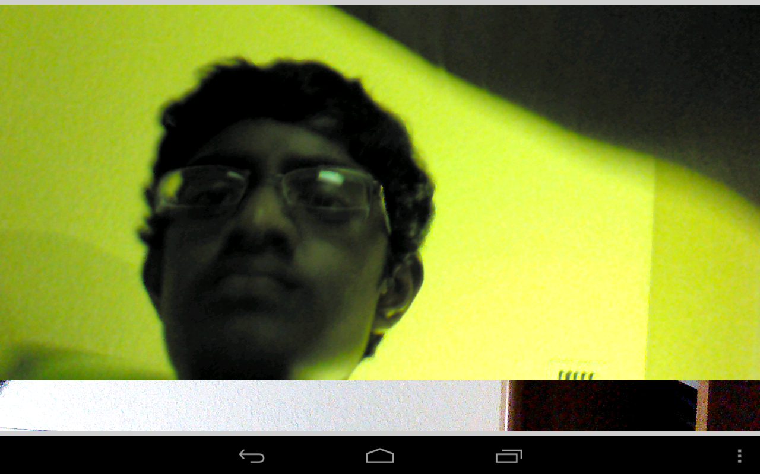

This app can also measure the distance and it prints the estimated distance from the camera to the green object in centimeters. Below is a picture of a green object in front of the camera.

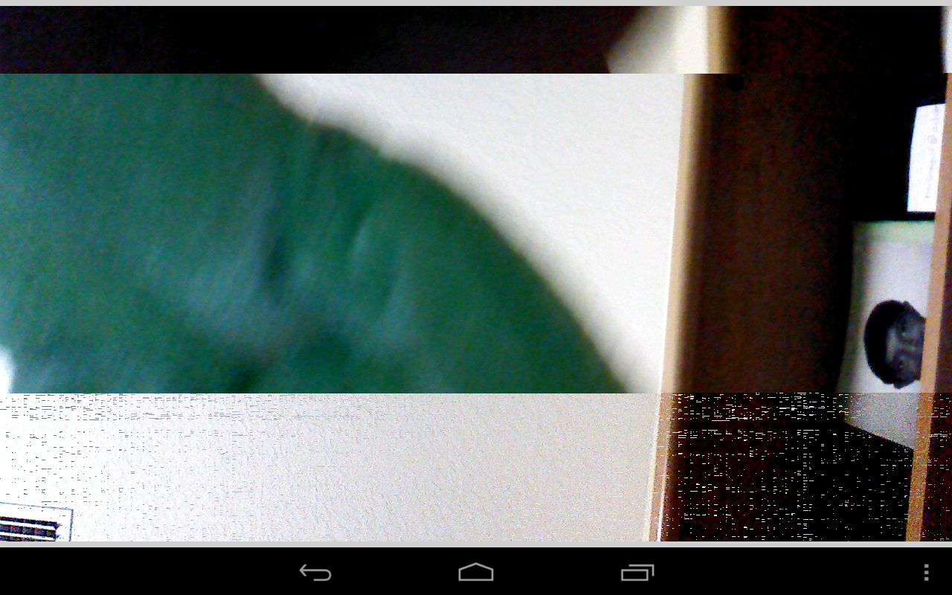

The estimated distance from the object to the distance was approximately 17 centimeters.